## Projecttitle

### DesignandAnalysisofE-BikeChassisFrame



VISVESVARAYA TECHNOLOGICALUNIVERSITY

JnanaSangama,BELGAUM

BACHELOR OFENGINEERING in*MECHANICALENGINEERING*

By

Student Name 1

Student Name 2

Student Name 3

Student Name 4

PRATHIK KAMATH HIMANSHUSHARMA GAURAV SHUKLA ROJIN K JOHN

USN 1DS14ME060 USN 1DS14ME055 USN 1DS14ME146 USN 1DS14ME117

Under the guidanceof Mr.KISHOREKUMAR

Asst. Professor,Dept. ofMechanicalEngg.,DAYANANDASAGARCOLLEGEOFENGINEERING,Bangalore



Department of Mechanical EngineeringDAYANANDASAGARCOLLEGEOFENGINEERING

SHAVIGEMALLESHWARAHILLS,KUMARSWAMYLAYOUT,BANGALORE-78

AccreditedbyNationalAssessmentandAccreditationCouncil(NAAC)with‘A’ grade

2017-2018

## DAYANANDASAGAR COLLEGEOFENGINEERING

SHAVIGEMALLESHWARA HILLS,KUMARSWAMYLAYOUT,BANGALORE-78

AccreditedbyNationalAssessment and AccreditationCouncil(NAAC) with ‘A’grade



## DepartmentofMechanicalEngineering

# CERTIFICATE

Thisistocertifythattheprojectworkentitled“**DesignandAnalysisofE-Bike Chassis Frame**”,carriedoutby**Mr.Prathik Kamath(1DS14ME060),Mr.HimanshuSharma (1DS14ME055),Kumar Gaurav(1DS14ME062)andRojin K John (1DS14ME117)** bonafide students of **Dayananda Sagar College of Engineering, Bangalore,**inpartialfulfilmentfortheawardofBachelorofEngineeringinMechanical EngineeringoftheVisveswaraiahTechnologicalUniversity,Belgaumduringthe year2017-2018.

Itiscertifiedthatallcorrections/suggestionsindicatedfortheInternalAssessmenthave beenincorporatedintheReportdepositedinthedepartmentallibrary.Theprojectreport hasbeenapprovedasitsatisfiestheacademicrequirementsinrespectofProject

workprescribedforthe said degree.

SignatureoftheGuide

SignatureoftheHOD SignatureofthePrincipal

[Mr.KishoreKumar] [Dr.R.Keshavamurthy] [Dr.C.P.SPrakash]

##### EXTERNAL VIVA

|  |  |  |
| --- | --- | --- |
|  | Name ofthe examiners | Signaturewith date |
| 1. |  |  |
| 2. |  |  |

# DECLARATION

We,**Mr.Prathik Kamath(1DS14ME060),Mr.Himanshu Sharma(1DS14ME055),Kumar Gaurav(1DS14ME062)andRojin K John(1DS14ME177),**herebydeclarethattheprojectworkentitled“**DesignandAnalysisofE-Bike Chassis Frame”**hasbeenindependentlycarriedoutbyusundertheguidanceof**Mr.Kishore Kumar,**AssistantProfessor,DepartmentofMechanicalEngineering,DayanandaSagarCollege ofEngineering,Bangalore, inpartialfulfilmentoftherequirementsofthedegreeofBachelorofEngineeringinMechanicalEngineeringofVisvesrayaTechnologicalUniversity,Belgaum.

Wefurtherdeclarethatwehavenotsubmittedthisreporteitherinpartorinfulltoanyotheruniversityforthereward of anydegree.

**NAME USN SIGNATURE**

Prathik Kamath 1DS14ME060

Himanshu Sharma 1DS14ME055

Kumar Gaurav 1DS14ME062

Rojin K John 1DS14ME117

Place:BangaloreDate:

# ABSTRACT

ThemainobjectiveofourprojectistoprovideamarketreadyElectricBikechassis meetingtheIndustryStandards.Inthisvarioustypeofchassisarebeingdesigned, analyzedandoptimizedtogivethemanufactureastableworkingchassis.Theseveral componentswillbeanalyzedseparatelyinsteadofasawholeand,insomecases,the reactionforcesinboundaryareasofsomepartswillbeusedasexternalloadsinother ones.Thestructuralanalysiswillbecomprisedofstaticanddynamicsimulationsforall thecomponentsandbucklinganalysisforpartsundercompressiveloads.Themethod appliedforthisstructuralanalysiswillbethefiniteelementmethodintheHypermeshfor preprocessing,ANSYSworkbenchforprocessingandThemainobjectiveofourproject istoprovideamarketreadyElectricBikechassismeetingtheIndustryStandards.Inthis varioustypeofchassisarebeingdesigned,analyzedandoptimizedtogivethe manufactureastableworkingchassis.Theseveralcomponentswillbeanalyzed separatelyinsteadofasawholeand,insomecases,thereactionforcesinboundaryareas ofsomepartswillbeusedasexternalloadsinotherones.Thestructuralanalysiswillbe comprisedofstaticanddynamicsimulationsforallthecomponentsandbucklinganalysis forpartsundercompressiveloads.Themethodappliedforthisstructuralanalysiswillbe thefiniteelementmethodintheHypermeshforpreprocessing,ANSYSworkbenchfor processing andpost processing whose CAD functions will also be used in order to provide alternate geometries for the motorcycle.

# ACKNOWLEDGEMETS

The finaloutcomeofthisassignmentrequiredalotofguidanceandassistancefrommanypeopleandwearefortunatetohavegotthisallalongthecompletionofmywork.Everythingwehavedoneisonlyduetosuchdirection.Theircontributionsaresincerelyappreciatedandgratefullyacknowledged.However,wewouldliketoexpressourdeepappreciationandindebtedness particularlyto the following:

Weextendourgratitudeto**Dr.CPSPrakash**,Principal,DayanandaSagarCollegeofEngineering, forthis opportunity.

WethanktheHeadoftheDepartmentofMechanicalEngineering,**Dr.R.Keshavamurthy**

forhis support.

Wewouldalsoliketothank**Mr.Kishore Kumar**forhisunendingsupportwithall things necessaryto seethecompletion of this assignment.

Wewouldalsoliketothankall ourfriends,relativesandotherswhoinoneoranotherwayshared theirsupport, either morallyor physically.

We Thank You.

# Contents

CERTIFICATE 1

DECLARATION 2

ABSTRACT 3

ACKNOWLEDGEMETS 4

LIST OF FIGURES 7

LIST OFTABLES 9

NOTATIONS

CHAPTER 1:INTRODUCTION

* 1. Overview
  2. Problem Statement
  3. Objectives

CHAPTER 2:LITERATUREREVIEW

* 1. Paper
  2. Articles
  3. Book

CHAPTER 3: METHODOLOGY

CHAPTER 4: MISSIONREQUIREMENTS

CHAPTER 5: CONCEPTUALDESIGN

5.1 PreliminaryAssumptions Made

* 1. FormulaeUsed
  2. Substitution

CHAPTER 6: PRELIMINARYDESIGN

CHAPTER 7: DETAILEDDESIGN/MODELLING

CHAPTER 8: FATIGUEANALYSIS

* 1. Methodologyof CFDanalysis 
     1. Pre– Processing
     2. Meshing
     3. Solution
     4. Post processing

CHAPTER 9: LINEAR STATICANALYSIS

* 1. Material Data
  2. PreProcessing
  3. Meshing
  4. Solution

CHAPTER 10: NON LINEAR(ELASTO-PLASTIC)ANALYSIS

10.1 Solution

CHAPTER 11: CRASH ANALYSIS 27

ADVANTAGESANDDISADVANTAGES 29

ADVANTAGES 29

DISADVANTAGES 29

FUTURE SCOPE 30

CONCLUSION 31

REFERENCES 32

# LIST OFFIGURES

# LIST OFTABLES

# NOTATIONS

# CHAPTER 1:INTRODUCTION

### Overview

The chassis frame forms the backbone of a vehicle; its principle function is to safely carry the maximum load for all designed operating conditions. Automotive chassis is the main carriage system of a vehicle. The chassis serves as a skeleton upon which parts like gearbox and engine are mounted. The two-wheeler chassis consists of a frame, suspension, wheels and brakes. The chassis is what truly sets the overall style of the two-wheeler. Commonly used material for two-wheeler chassis is steel which is heavy in weight or more accurately in density. There are various alternate materials like aluminum alloys, titanium, carbon fiber, magnesium, etc.

With this project we attempt to design an entirely new chassis design concept which can be used in an Electric Bike subjected to various loading conditions like static and dynamic loadings on the chassis and the design is optimized by reducing the weight of the chassis by using alternate material and geometries while maintaining the strength.

We look forward to adhere to the spirit of design and create a stable, working and ready to manufacture bike chassis by various analysis, good engineering concepts and techniques.

### ProblemStatement

Designandanalyze a market ready E-Bike Chassis Frame.

### Objectives

* In order to create an efficient design, one needs to
* Identify the needs and define the problem statement which in this case is to Design an Efficient Electric Bike Chassis.
* Research the problem which includes understanding the need for chassis, the best material to use, best geometries etc. required to create a stable chassis.
* Plan and design by selecting a promising solution obtained by various manual calculations and data collected during the research.
* Testing and optimization of the design under various loads and physical conditions.
* Improving the design in order to overcome various faults and shortcomings of the design based on the test phase.

# CHAPTER 2: LITERATUREREVIEW

### Paper

* Motorcycle Handling and Chassis Design by Tony Foale.
* Motorcycle Chassis Analysis
  + IDMEC/IST, Institute of Mechanical Engineering, Instituto Superior Técnico, University of Lisbon, Portugal
* MODELLING AND STRUCTURAL ANALYSIS OF TWO WHEELER FRAME
  + YMCA Institute of Engineering, Faridabad, Haryana
* A Review on Design and Analysis of Two Wheeler Chassis
  + Professor Ram Meghe Institute of Technology & Research Badnera,Amravati, India.

### Articles

### Book

# 

# CHAPTER 3: METHODOLOGY

**Methods**

* Initial layout of chassis through ergonomics and reverse engineering using 3D CAD modeling and Pug matrix optimization.
* Comparing the bending ,torsional & longitudinal stiffness with the standards and updating the chassis frame to the required stiffness using the strength of materials and through numerical approximations using FEA.
* Performing the crash analysis ,vibrational analysis and structural analysis to meet up with the road safety norms & updating the chassis depending on these results.

**Methodology**

* Seating positions are derived from reverse engineering techniques. CAD modeling is done on CATIA & Unigraphix.
* Preprocessing is done in hypermesh by using shell 181p element for 2d meshing. Maintaining different mesh style for crash and durability mesh.
* Elasto plastic analysis is done for localized high stress regions after neuberization by using multilinear kinematic data. Fatigue life is estimated for these regions and design is updated for high cycle fatigue life. Vibrational analysis is done by considering the vibrations forced on the chassis through the motor and the belt along with the vibration coming due to tires.
* Finally crash analysis is done through LS Dyna to meet up with the road safety norms and chassis design is updated.

# CHAPTER 4:MISSION REQUIREMENTS

* To lay a groundwork and research about various types of chassis.
* Figure out how different an Electric Vehicle chassis is when compared to the Fuel Operated ones.
* Choose and Design an optimum chassis.
* Undertake different types of Analysis on the chassis to make it industry ready.
  + Crash Analysis
  + Nonlinear Analysis
  + Structural Analysis
  + Fatigue Analysis
  + Vibrational Analysis

# 

# CHAPTER 5: CONCEPTUALDESIGN

### PreliminaryAssumptionsMade

### Material properties are isotropic.

### Swing arm is modelled just give the real time approximation in the assembly by giving proper location for supports.

### Spring element is used to simplify the modelling without using damping properties as dynamic loading is not considered.

### One node is fixed in the handle bar bearing to avoid solver pivotal error.

# 

# CHAPTER 6: PRELIMINARYDESIGN

After thorough research work and considering various factors like cost,stability and feasibility, a final chassis was designed and all the tests and analysis are done on the same.

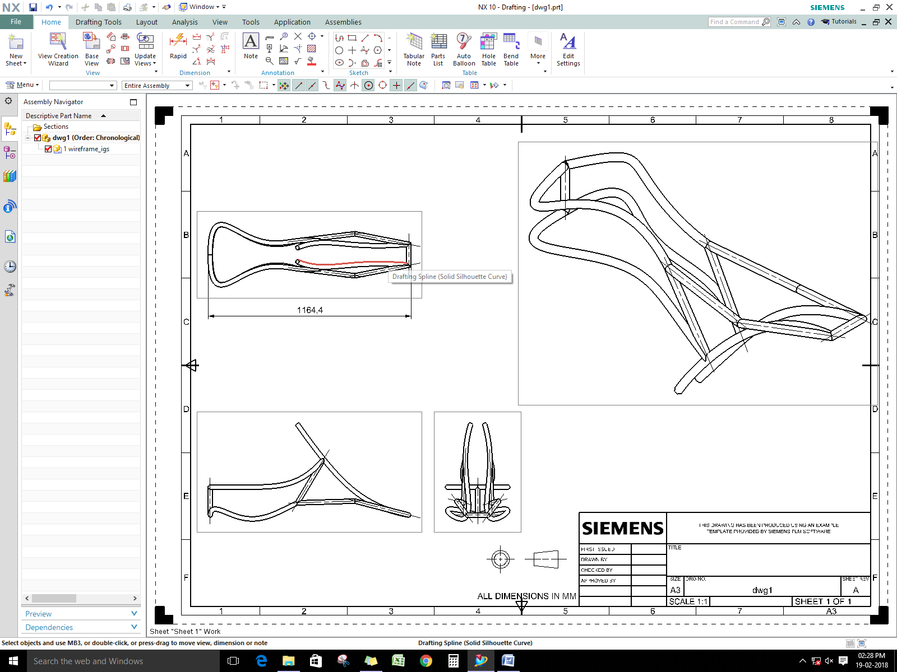

FIGURE final design of chassis frame

# CHAPTER 7: DETAILEDDESIGN/MODELLING

# 

# 

# 

# 

# CHAPTER 8: FATIGUE ANALYSIS

# 

# 

# Figure chassis with loads and Boundary conditions applied

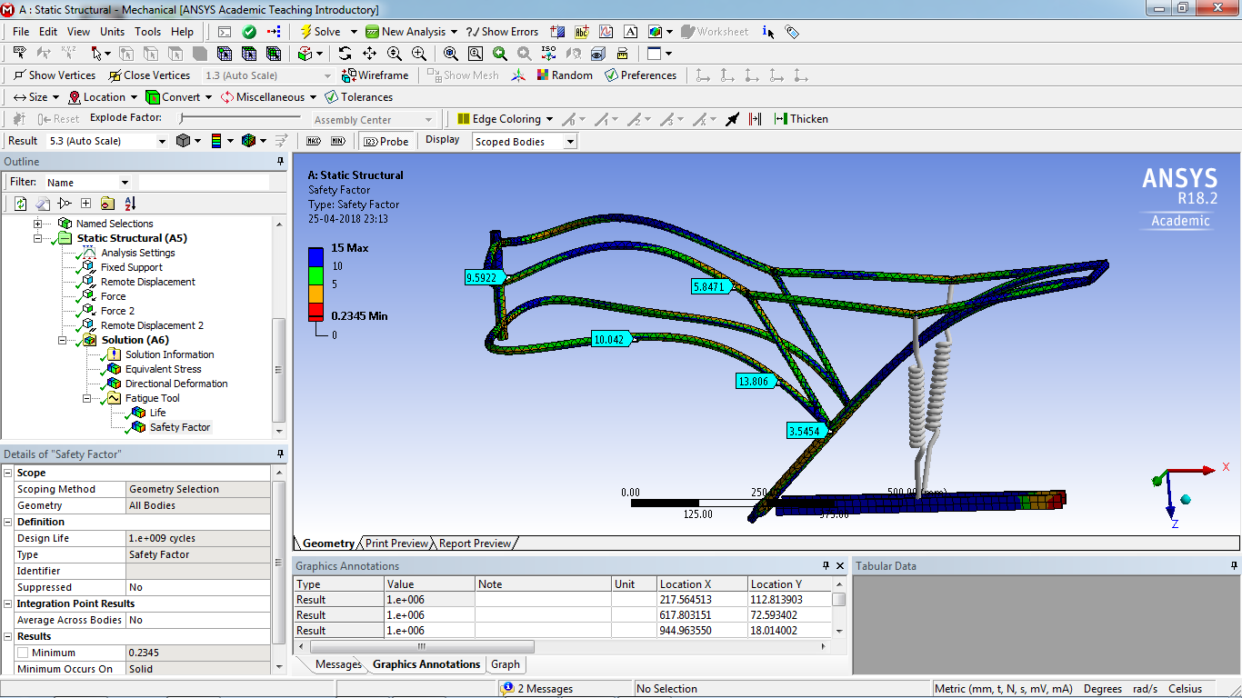**Safety Factor**

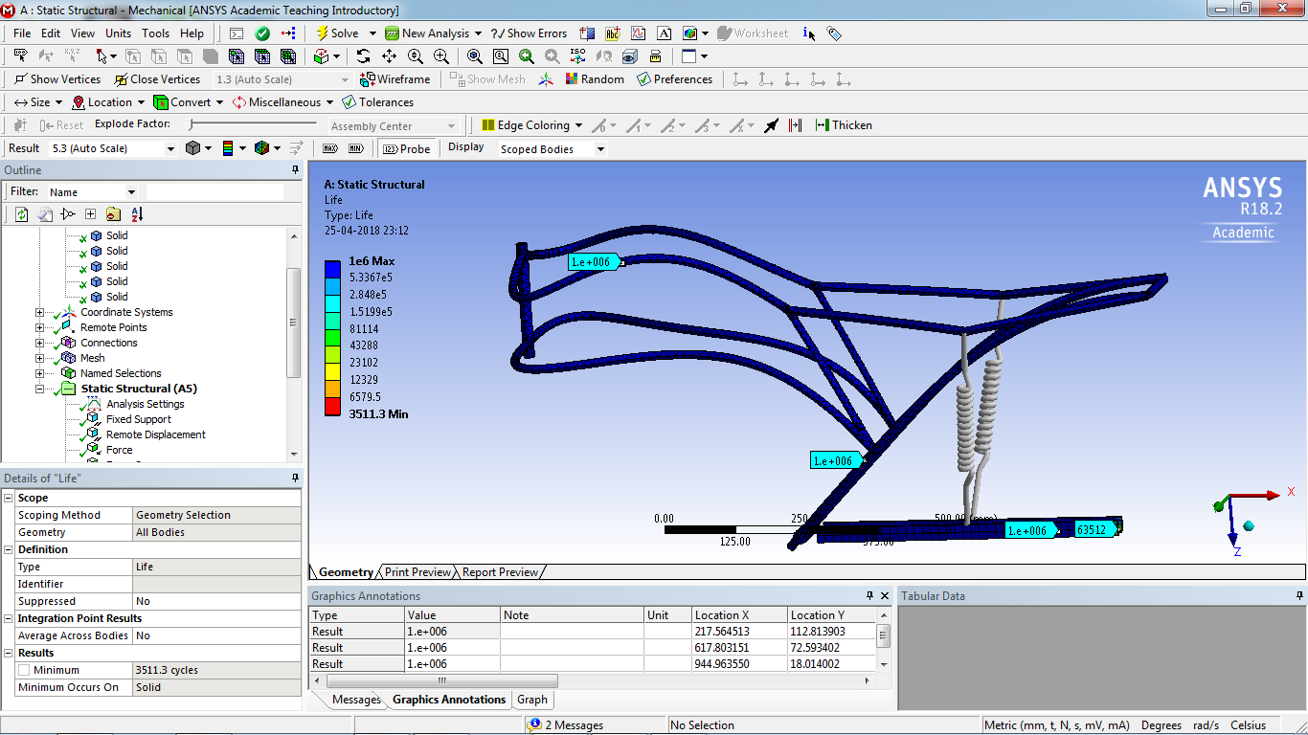**Life**

# CHAPTER 9: STATICLINEARANALYSIS

### MaterialData

From the properties obtained from different materials the finalized material is aluminium 6061 t6 grade metal for the chassis.

Following are the key properties for the finalization:

* T6 temper 6061 has an ultimate tensile strength of at least 290 MPa (42,000 psi) and yield strength of at least 240 MPa (35,000 psi).
* Aluminium 6061 t6 has one-third the density and one-third the modulus of steel – the diameter of the aluminium bar needs to be larger by 32 per cent, at which its weight will be only 58 per cent of that of the steel bar.
* Cost is comparably low.
* 6061 is highly weldable, for example using [tungsten inert gas welding](https://en.wikipedia.org/wiki/Tungsten_inert_gas_welding) (TIG) or [metal inert gas welding](https://en.wikipedia.org/wiki/Metal_inert_gas_welding) (MIG).
* 6061 has good fatigue behavior with fatigue strength of 125 mpa.

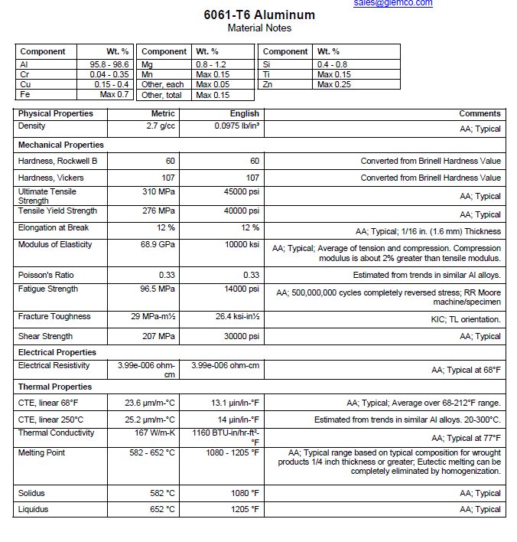

### PreProcessing

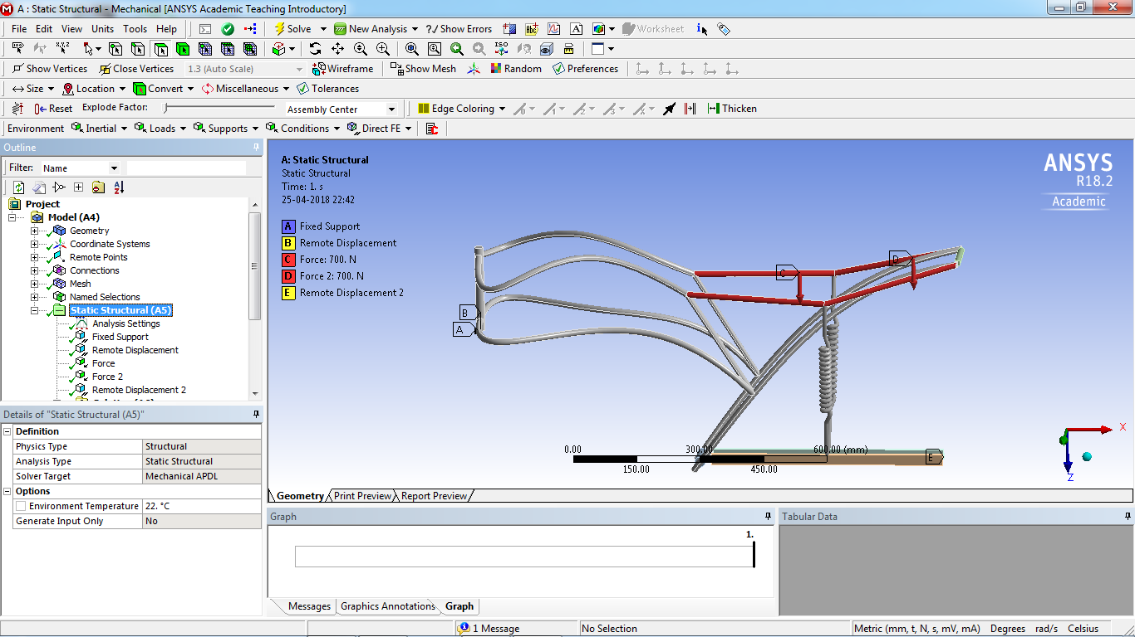

Figure chassiswith loadsandBoundary conditionsapplied

### Meshing

Meshing isthediscretizationofamodelintosmallelementscontainingnodesfor detailedanalysis.ANSYSFluentcanusemeshescomprisedoftriangularorquadrilateralcells(oracombinationofthetwo)in2D,andtetrahedral,hexahedral,polyhedral,pyramid,orwedgecells(oracombinationofthese)in3D.Thechoiceofwhichmeshtypetousewilldepend onyourapplication. When choosingmeshtype,consider thefollowingissues:

* + - setup time
    - computational expense
    - numericaldiffusion

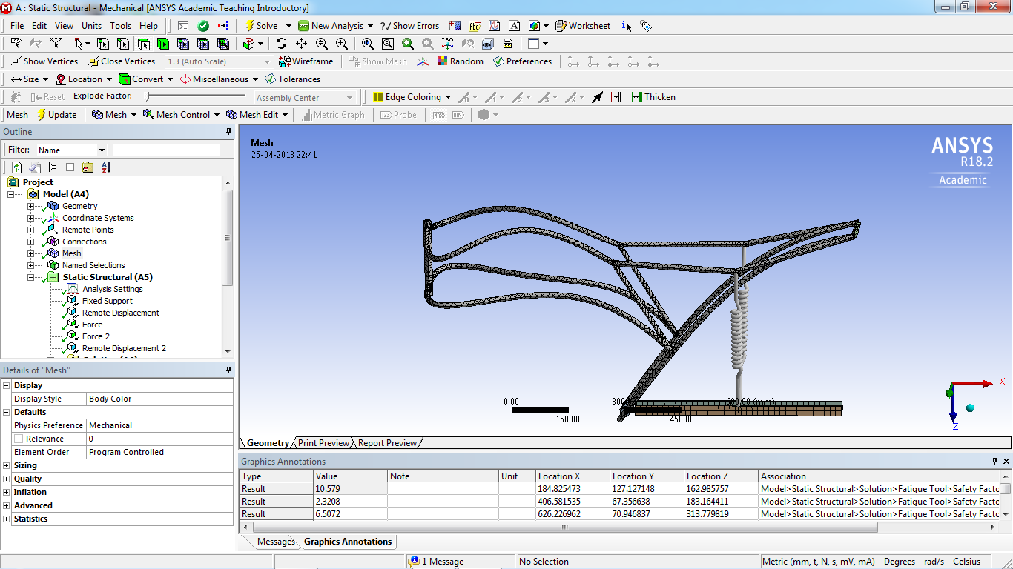

Figure Meshed chassis Section

### Solution

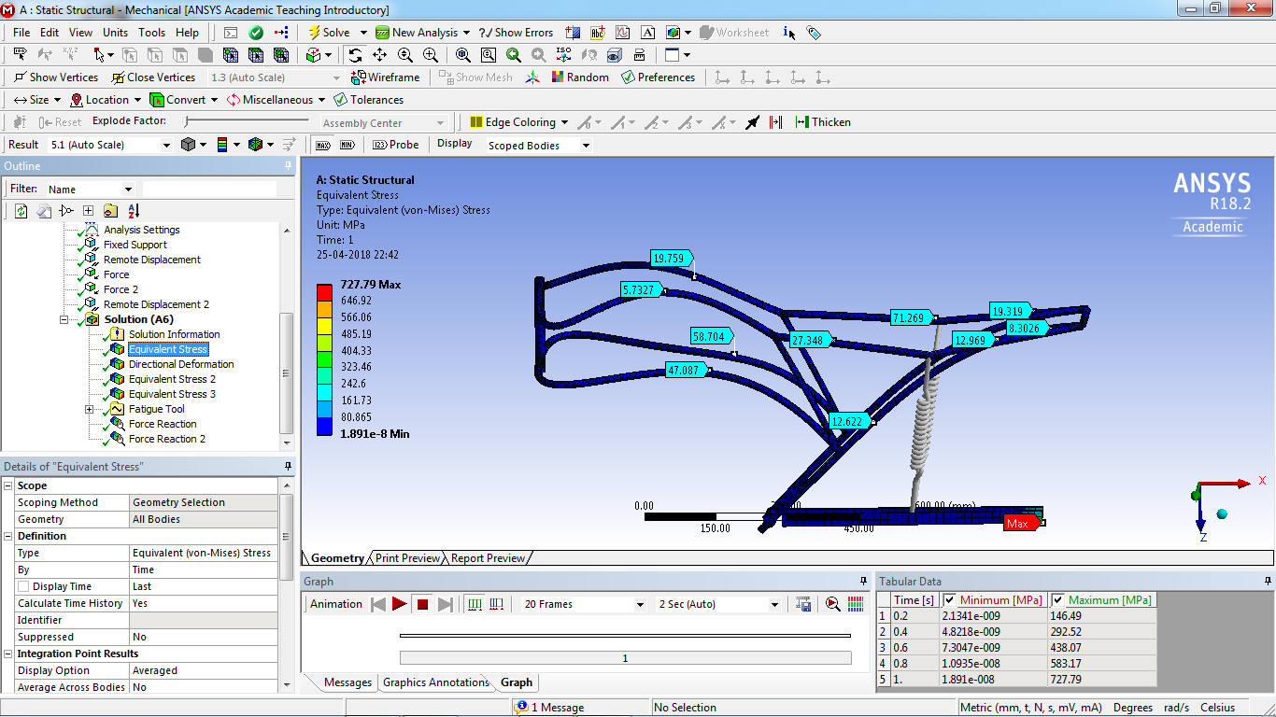

# CHAPTER10:NON LINEAR(ELASTO-

# PLASTIC)ANALYSIS

# 

# 

# 

# 

### 

### 

### Figure Meshed chassis Section

### 

### FigureLoading and boundary conditions

### 

### Figuresettings for non-linear control

### FigureResult

### 

# CHAPTER 11: CRASH ANALYSIS

# 

# 

### 

Figure chassiswith loadsandBoundary conditionsapplied

### 

### Figure Deformed model

### 

### Figure Energy Summary

### ADVANTAGES AND DISADVANTAGES

### ADVANTAGES

* + - Economical
    - SturdyModel
    - SafeLanding
    - Covers ALarge AreaInShort Time

### DISADVANTAGES

* + - Larger Computational Time
    - Requires Skilled Operator
    - Not SuitableForUnfavourableWeather Condition

# FUTURE SCOPE

# 

# CONCLUSION

* The chassis design in static analyses shows a working stress of 110Mpa well within the yield point, but we can scale the number *2 for conversion of dynamic loads to static loads & still having a FOS of 1.26
* Exact numbers of stress values are obtained in non linear analysis just to be on the conservative side just in case of geometric non linarites like stress stiffening.
* The designed chassis can survive in high cycle fatigue thus infinite life.
* The deformations of the chassis with frontal impact test at different speeds shows that the critical part i.e. the location of the battery is not disturbed.

# REFERENCES

[1]-[www.iosrjournals.org/iosr-jmce/papers/vol11-issue4/Version-3/J011435659.pdf](http://www.iosrjournals.org/iosr-jmce/papers/vol11-issue4/Version-3/J011435659.pdf)

[2]–http://www.capalex.co.uk/standards/round_tubes.html

[3]– <https://www.motorcyclistonline.com/ducati-desmosedici-rr-85-percent-solution>

[4]-<http://doras.dcu.ie/19502/1/Ping_Hwa_20130725155530.pdf>

[5]– http://www.amesweb.info/Materials/Aluminum-6061-Properties.aspx

[6]-https://www.makeitfrom.com/material-properties/SAE-AISI-4130-SCM430-1.7218-25CrMo4-G41300-Cr-Mo-Steel